**Glendale Chamber Site Plan**

**Site Purpose**:

The Glendale Chamber website is for the Glendale, AZ Chamber of Commerce. Its purpose is to help businesses in the city foster a strong network and help make connections. This chamber is focused on helping to strengthen the business interests of the city to help improve the well-being of all its citizens. This is a place where new, old, large or small businesses can join and get more advertisement to improve their business.

**Site Logo**:

**Target Audience**:

The intended visitors of Glendale Chambers are the Chamber members, business owners, entrepreneurs and job seekers living in Glendale, Arizona.

Age: 18-100

Gender: Male/Female

Location: Glendale, Arizona

Language: American English, Spanish

Education: High School Diploma, Associate, Bachelor’s, Minor, Masters or PhD level.

Income: $1,000 - 200,0000+

**Target Scenarios:**

What is the Glendale Chamber?

Where can I find contact information for businesses around the community?

Where can I go to join the Chamber?

Where does the Glendale Chamber meet?

How can I advertise my business on this site?

Who is a part of the Board of Directors?

**Site Map**:

**Color Scheme**: <https://coolors.co/fc4949-fecbcb-000000-ffffff>

|  |  |  |
| --- | --- | --- |
| **Color Type** | **Color** | **Sample** |
| Primary | #FC4949 | Sample |
| Secondary | #FECBCB | Sample |
| Dark | #000000 | Sample |
| Light | #FFFFFF | Sample |

**Typography:**

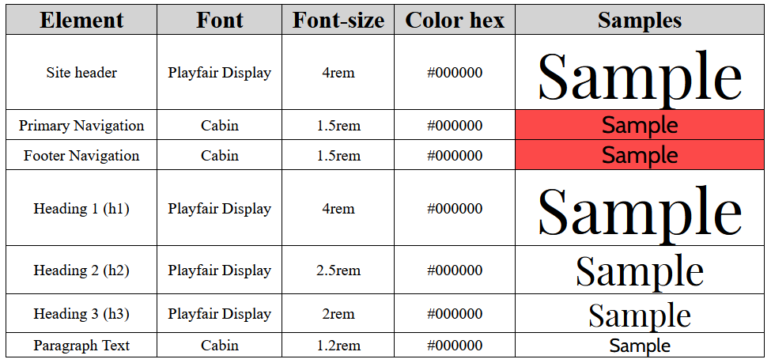

**Wireframe Sketches:**

**Desktop View -**

**Tablet View - Mobile View -**

